Self-Assessment Questions
Topic- Joule-Thomson Effect
1. Joule-Thomson effect is also called______?
a) Isothermal expansion of ideal gases
b) Isothermal compression of ideal gases
c) Adiabatic expansion of real gases
d) All of the above
2. What is the process in which no heat enters or leaves the system?
- Isobaric process
- Adiabatic Process
- Isothermal Process
- Isochoric process
3. In Joule-Thomson experiment, the gas is made to expand adiabatically from ____ region to _____ region through porous plug?
a) High pressure, Low pressure
b) Low pressure, High pressure
c) High pressure, High pressure
d) Low pressure, Low pressure
4. Find out the expression of Joule-Thomson Coefficient?
a) 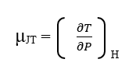
b) 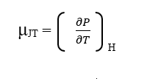
c) 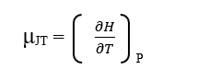
d) 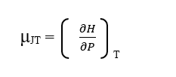

5. If μ_{JT} is positive,----?
- The gas cools on adiabatic expansion
- The gas warms on adiabatic expansion
- The gas neither cools nor warms up on adiabatic expansion
- No effect

6. If μ_{JT} is Negative,----?
- The gas cools on adiabatic expansion
- The gas warms on adiabatic expansion
- The gas neither cools nor warms up on adiabatic expansion
- No effect
7. What is the temperature at which the Joule-Thomson coefficient of a gas becomes zero?
a) Inversion temperature
b) Internal temperature
c) Intrinsic temperature
d) all of the above

8. What is the expression of Inversion temperature?
a) T_{i} = 2b / Ra
b) T_{i} = 2a / Rb
c) T_{i} = 2a / Ra
d) T_{i} = 2a / Rb²

9. Which technique is used to liquefy the gases in Linde liquefaction process?
a) Expansion of ideal gases
b) Isothermal compression of real gases
c) Isothermal expansion of real gases
d) Joule-Thomson effect
10. Joule-Thomson effect is used to liquefy what type of gases?
a) only ideal gases
b) real gases
c) only noble gases
d) all types of gases

Answers:
- (c) Adiabatic expansion of real gases
- (b) Adiabatic Process
- (a) High pressure, Low pressure
- (a)
- (a) The gas cools on adiabatic expansion
- (b) The gas warms on adiabatic expansion
- (a) Inversion Temperature
- (b) T_{i} = 2a / Rb
- (d) Joule-Thomson effect
- (b) real gases

